DEEP AUTOENCODING GAUSSIAN MIXTURE MODEL

FOR UNSUPERVISED ANOMALY DETECTION

ABSTRACT

Our model utilizes a deep autoencoder to generate a low-dimensional representation and reconstruction error for each input data point, which is further fed into a Gaussian Mixture Model (GMM).

1 INTRODUCTION

At the core of anomaly detection is density estimation: given a lot of input samples, anomalies are those ones residing in low probability density areas. To address this issue caused by the curse of dimensionality, two-step approaches are widely adopted, in which dimensionality reduction is first conducted, and then density estimation is performed in the latent low-dimensional space.

First, DAGMM preserves the key information of an input sample in a low-dimensional space that

includes features from both the reduced dimensions discovered by dimensionality reduction and

the induced reconstruction error.

Second, DAGMM leverages a Gaussian Mixture Model (GMM) over the learned low-dimensional

space to deal with density estimation tasks for input data with complex structures, which are yet

rather difficult for simple models used in existing works.

Finally, DAGMM is friendly to end-to-end training.

2 RELATED WORK

Reconstruction based methods assume that anomalies are incompressible and thus cannot be effectively reconstructed from low-dimensional projections. However, the performance of reconstruction based methods is limited by the fact that they only conduct anomaly analysis from a single aspect, that is, reconstruction error. Unlike the existing reconstruction based methods, DAGMM considers the both aspects, and performs density estimation in a low-dimensional space derived from the reduced representation and the reconstruction error caused by the dimensionality reduction, for a comprehensive view.

Clustering analysis is another popular category of methods used for density estimation and anomaly detection.

In addition, one-class classification approaches are also widely used for anomaly detection. DAGMM extracts useful features for anomaly detection through non-linear dimensionality reduction realized by a deep autoencoder, and jointly learns their density under the GMM framework by mixture membership estimation, for which DAGMM can be viewed as a more powerful deep unsupervised version of adaptive mixture of experts (Jacobs et al. (1991)) in combination with a deep autoencoder. More importantly, DAGMM combines induced reconstruction error and learned latent representation for unsupervised anomaly detection.

3 DEEP AUTOENCODING GAUSSIAN MIXTURE MODEL

3.1 OVERVIEW

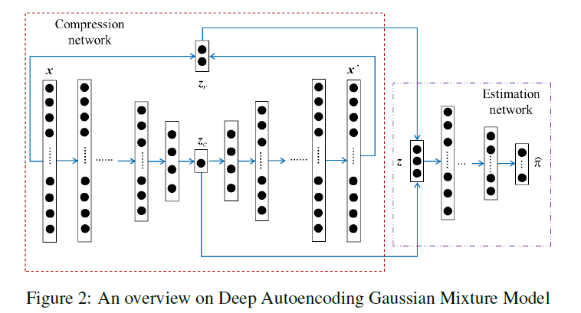

Deep Autoencoding Gaussian Mixture Model (DAGMM) consists of two major components: a compression network and an estimation network.

3.2 COMPRESSION NETWORK

The low-dimensional representations provided by the compression network contains two sources of

features: (1) the reduced low-dimensional representations learned by a deep autoencoder; and (2) the features derived from reconstruction error.

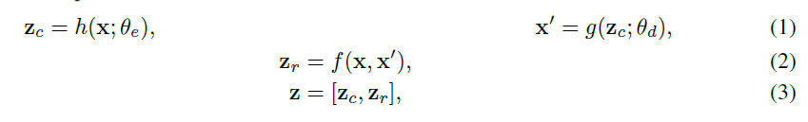

3.3 ESTIMATION NETWORK

Given the low-dimensional representations for input samples, the estimation network performs density estimation under the framework of GMM.

The estimation network achieves this by utilizing a multi-layer neural network to predict the mixture

membership for each sample. Given the low-dimensional representations z and an integer K as the

number of mixture components, the estimation network makes membership prediction as follows.



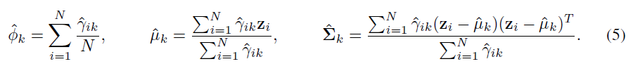

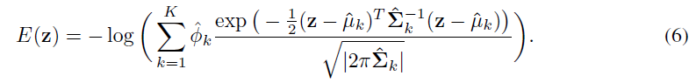

3.4 OBJECTIVE FUNCTION

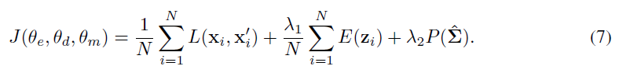

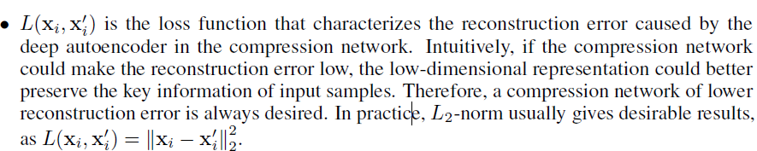



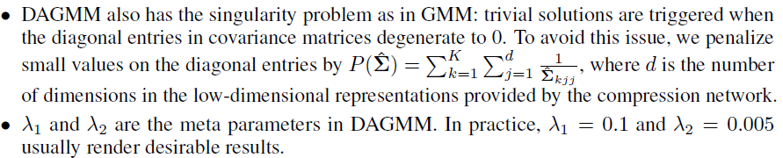

3.5 RELATION TO VARIATIONAL INFERENCE

3.6 TRAINING STRATEGY

4 EXPERIMENTAL RESULTS

4.1 DATASET

We employ four benchmark datasets: KDDCUP, Thyroid, Arrhythmia, and KDDCUP-Rev.

4.2 BASELINE METHODS

4.3 DAGMM CONFIGURATION

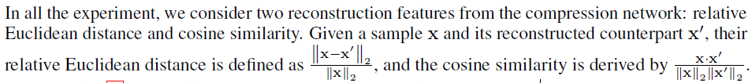

4.4 ACCURACY

Metric. We consider average precision, recall, and F1 score as intuitive ways to compare anomaly

detection performance.

4.5 VISUALIZATION ON THE LEARNED LOW-DIMENSIONAL REPRESENTATION

5 CONCLUSION

DAGMM consists of two major components: compression network

and estimation network, where the compression network projects samples into a low-dimensional

space that preserves the key information for anomaly detection, and the estimation network evaluates sample energy in the low-dimensional space under the framework of Gaussian Mixture Modeling.